Reception Home Learning Pack

Focus book : Kipper’s Snowy Day
9am | 9.30am | 10am | 10.15am | 10.45am | 10.45am | 11am | 12pm
Phonics  (see attached phonics overview) | Reading – this could be their reading for pleasure book or their ebook (online) | English – Kipper’s Snowy Day | Snack and Play | Maths  White Rose “Building 9 and 10”  Building 9 and 10 | Wake up shake up break  Cosmic Kids/Joe Wicks (available on youtube) | Play/busy time  Key words/Tricky word practice | Encourage your child to prepare lunch with you!

Focus: children focus better on structured activities during the morning. Try to keep the afternoons more flexible with topic based activities and more indoor and garden/outdoor play.
Play: interact with your child by playing board games and card games.
Get out the Lego and construction toys!
Play games based on the text of the week (Kippers Snowy Day), dress up, act out stories, make believe.
Explore: go for a walk (if you can), gather treasures you find, draw pictures, take photos, look for signs of seasonal change, what changes can you see around you?
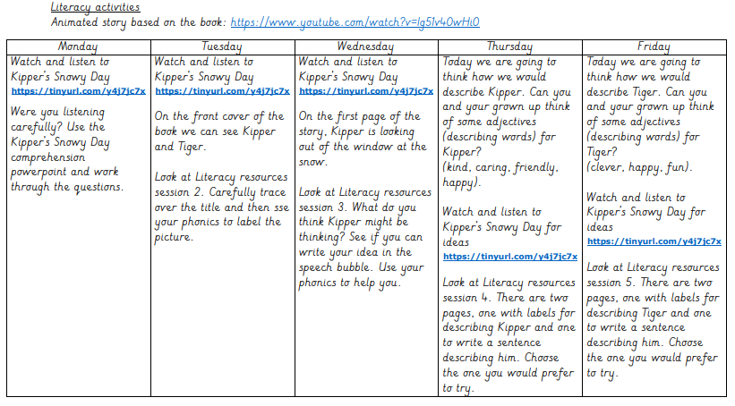

Top tips for using phonics to help with writing:
1.Encourage your child to sound out the word/s that they wish to write e.g. if they want to write hat, ask them what sound the word starts with. What is the next sound? Help your child to stretch out the sounds in the word by saying the word slowly e.g. hhhh-aaaa-tttt.
2.Encourage using a capital letter at the start of each sentence and a full stop at the end.
3. If they are writing a sentence or a caption, support them with using finger spaces between each word. 4. Encourage your child to record words/sentence on the lines going from left to right.

